

Quality of primary
health care in Georgia

Quality of primary
health care in Georgia

WHO European Centre for Primary Health Care
Health Services Delivery Programme
Division of Health Systems and Public Health


WHO European Framework for Action
on Integrated Health Services Delivery

Draft for discussion
12 March 2018

Abstract
This report presents the findings of an assessment of quality of care in primary health care in Georgia. To advance the agenda for universal health coverage in Georgia, this work was set out to support the Ministry of Labour, Health and Social Affairs in operationalizing the Primary Health Care Strategic Plan 2016–2023. The report presents policy directions to strengthen the quality of primary health care.

Keywords

DELIVERY OF HEALTHCARE
HEALTH SERVICES
PRIMARY HEALTH CARE
QUALITY OF CARE
GEORGIA

Address requests about publications of the WHO Regional Office for Europe to:
Publications
WHO Regional Office for Europe
UN City, Marmorvej 51
DK-2100 Copenhagen Ø, Denmark
Alternatively, complete an online request form for documentation, health information, or for permission to quote or translate, on the Regional Office website (http://www.euro.who.int/pubrequest).

© World Health Organization 2018

All rights reserved. The Regional Office for Europe of the World Health Organization welcomes requests for permission to reproduce or translate its publications, in part or in full.
The designations employed and the presentation of the material in this publication do not imply the expression of any opinion whatsoever on the part of the World Health Organization concerning the legal status of any country, territory, city or area or of its authorities, or concerning the delimitation of its frontiers or boundaries. Dotted lines on maps represent approximate border lines for which there may not yet be full agreement.
The mention of specific companies or of certain manufacturers’ products does not imply that they are endorsed or recommended by the World Health Organization in preference to others of a similar nature that are not mentioned. Errors and omissions excepted, the names of proprietary products are distinguished by initial capital letters.
All reasonable precautions have been taken by the World Health Organization to verify the information contained in this publication. However, the published material is being distributed without warranty of any kind, either express or implied. The responsibility for the interpretation and use of the material lies with the reader. In no event shall the World Health Organization be liable for damages arising from its use. The views expressed by authors, editors, or expert groups do not necessarily represent the decisions or the stated policy of the World Health Organization.

Contents

Abbreviations iv
List of figures, tables and boxes iv
Acknowledgements v

Background 1
Methods 2
Health status and risk factors 4
Primary health care delivery system 6
Organization and governance of primary health care 6
People-centredness 9
Accountability of health providers 10
Performance, data and feedback learning loops 10
Regulatory capacity 11
Capacity at the subnational level 11
Quality in primary health care 13
Setting and enforcing standards 13
Mechanisms for ensuring quality of processes 14
Mechanisms for ensuring the quality of outputs and outcomes 17
Policy directions for improvements 19
Opportunities for strengthening the system for primary health care delivery 19
Opportunities for improving quality in primary health care 21
Final remarks 24

References 25
Annex 1. Multi-stage process for strengthening primary health care governance 26

Abbreviations

EU European Union
ICD-10 International Classification of Diseases, 10th revision
TB tuberculosis
UNFPA United Nations Population Fund
UNICEF United Nations Children’s Fund

List of figures, tables and boxes

Figures

Fig. 1. Overview of the European Framework for Action on Integrated Health Services Delivery 2
Fig. 2. Proportional mortality 2014 (% of total deaths, all ages, both sexes) 4
Fig. 3. Quality of care continuum 13

Tables

Table 1. Variables reviewed in the assessment applying the European Framework for Action on Integrated Health Services Delivery 3
Table 2. Top 10 causes of death by rate in 2015 and change, 2005–2015 4
Table 3. Primary health care policy milestones in Georgia 6
Table 4. Primary health care services, providers and settings 7
Table 5. Dedicated health programmes 8
Table 6. Key actors at the national and subnational levels 12
Table 7. Summary of mechanisms for assuring quality of inputs 15

Boxes

Box 1. Rural doctors and chronic disease management 9
Box 2. Management for performance at the Tbilisi Family Medicine Training Centre 11
Box 3. Innovations in continuing professional development 16
Box 4. Peer-review meetings 17

Acknowledgements

This report is the result of the shared commitment of the Ministry of Labour, Health and Social Affairs of Georgia and the WHO Regional Office for Europe in the context of the biennial collaborative agreement.
The document was edited by Paola Abril Campos Rivera, Harvard T.H. Chan School of Public Health, Juan Tello and Erica Barbazza, WHO Regional Office for Europe, based on the contributions of Margrieta Langins, Altynai Satylganova and Evgeny Zheleznakov, WHO Regional Office for Europe and Alexandre Lourenco, Coimbra Hospital and Universitary Centre.
The WHO Country Office in Georgia provided insight and overall coordination of the assessment under the leadership of Marijan Ivanusa; Rusudan Klimiashvili and Nino Mamulashvili.
Valuable input was received from representatives of the following organizations: Ministry of Labour, Health and Social Affairs; National Centre for Disease Control and Public Health; Municipality of Tbilisi; Public Health Centre of the Sagarejo Region; Tbilisi Family Medicine Training Centre; Tbilisi State Medical University; Georgian Society of Hypertension; Georgian National Nursing Association; Winner Women’s Club; and providers: Curatio Private Clinic; Regional Multi-profile Medical Centre in Sagarejo; Sartichala Rural Ambulatory Centre; Lashvili Central Children’s Hospital; and Gudushauri Multiprofile Hospital; and development partners: Development Cooperation for the Czech Republic, UNICEF and UNFPA.
The document was technically reviewed by Juan Tello, WHO Regional Office for Europe.
We acknowledge the funding support from the Government of Kazakhstan within the context of the WHO European Centre for Primary Health Care.

Background

In the past five years, considerable policy strides have been made in Georgia to transform services delivery based on a primary health care approach and embracing universal health coverage. The Georgian Health System State Concept 2014–2020 on universal health coverage and quality control defines these actions as does the launch of a universal health coverage programme in 2013, introducing a social health insurance model to extend basic coverage (1).

This assessment was organized in the context of the EU-Luxembourg-WHO Universal Health Coverage Partnership. A universal health coverage partnership action plan covering July–December 2017 envisages WHO support for operationalizing the Primary Health Care Strategic Plan 2016–2030. More specifically, the universal health coverage partnership activity calls for developing mechanisms for improving quality in primary care to strengthen governance.
This assessment follows an earlier scoping mission on health services delivery in July 2016 and constitutes an effort to further describe and analyse the current situation and initiatives undertaken to improve the quality and overall governance of primary health care.
The scope of the assessment is aligned with other ongoing WHO initiatives in technical assistance. These initiatives and their related findings were fully integrated into this assessment to ensure the harmonization of overall policy directions and the complementarity of efforts. The assessment emphasized coordinating efforts in strategic purchasing, tackling noncommunicable diseases and nutrition, continuing endeavours to integrate public health services and the response to tuberculosis (TB).

This report has four main sections. The first section provides an overview of key health outcomes as drivers for transforming health services delivery. The second section provides an overview of the organization and governance of the system for delivering primary health care. The third section describes the mechanism for ensuring the quality of inputs, processes, outputs and outcomes. The fourth section provides directions for improvement through concrete action-oriented policy recommendations.

The report extensively highlights the good practices and innovations in service delivery observed during the field visits.

Methods

This assessment draws on a desk review and on interviews and direct observations during a visit to Georgia from 24 to 28 July 2017.

Documents published in recent years were reviewed and analysed. Some are publicly available (5,6,7); the Ministry of Labour, Health and Social Affairs shared others (2,3). The review of these documents provided solid understanding of health status and the challenges the health system currently faces.

Questionnaires were then developed with the aim of filling knowledge gaps to guide the interviews during the in-country period.

The assessment team had multidisciplinary competencies on policies, accountability and overall governance and on quality of clinical practice. Through semistructured interviews, the assessment team sought first-hand insight from the Ministry of Labour, Health and Social Affairs, national counterparts, providers and professional associations on the current challenges related to the quality of primary health care and explored options for improvement.

The assessment team met with representatives of the Ministry of Labour, Health and Social Affairs, National Centre for Disease Control and Public Health, the Municipality of Tbilisi and diverse health-care facilities, including a children’s hospital, a multi-profile hospital, the Tbilisi Family Medicine Training Centre and a rural ambulatory centre. The team also interviewed members of professional associations and patients’ clubs and met representatives of development partners.

The assessment was guided by the principles of the European Framework for Action on Integrated Health Services Delivery (4) and its approach to transforming health services delivery (Fig. 1).

Fig. 1. Overview of the European Framework for Action on Integrated Health Services Delivery
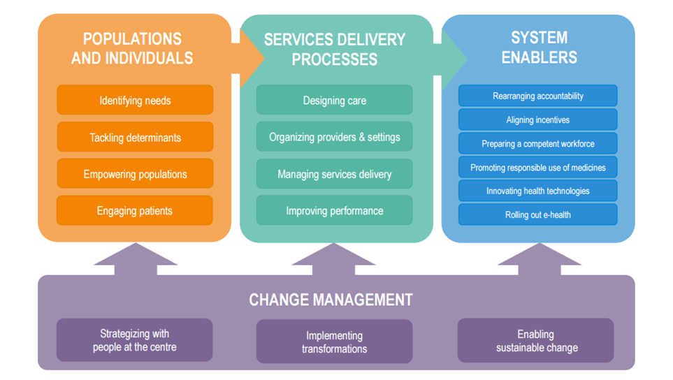
Source: (4)

The assessment used selected variables from the European Framework for Action on Integrated Health Services Delivery (Table 1).

Table 1. Variables reviewed in the assessment applying the European Framework for Action on Integrated Health Services Delivery
Domain | Areas | Variables
Populations and Individuals | Identifying needs | - Identifying patient population health needs
Services delivery processes | Designing care  Organizing providers and settings  Managing services delivery  Improving performance | - Structuring primary care practices  - Determining the mix of disciplines  - Use of clinical guidelines and protocols  - Organization of providers and settings for equitable access  - Patient transitions, referrals and discharge  - Measuring performance and the quality of care
System enablers | Rearranging accountability | - Aligning organizational structures
System enablers | Aligning incentives | - Matching provider incentives to services
System enablers | Ensuring a competent workforce | - Recruiting and training primary care staff members

Health status and risk factors

Life expectancy in Georgia has been increasing slowly in recent years, with a growing number of older people living with chronic and comorbid conditions.

A high prevalence of smoking and alcohol use and communicable diseases such as hepatitis C and TB coexist with the increasing burden of noncommunicable diseases.

Noncommunicable diseases
Noncommunicable diseases account for an estimated 93% of total deaths in Georgia. 69% of those are due to cardiovascular diseases (Fig. 2) (5).

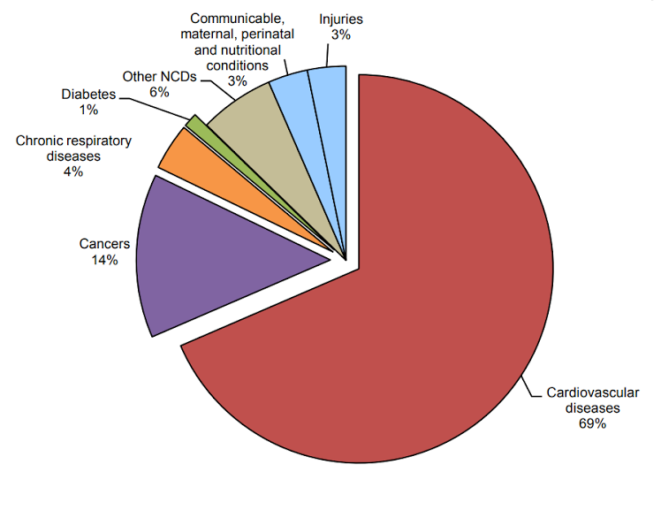
Fig. 2. Proportional mortality 2014 (% of total deaths, all ages, both sexes)
NCDs: noncommunicable diseases.
Source: Noncommunicable disease country profile: mortality structure, Georgia (5).

Three cardiovascular diseases are the leading causes of death in Georgia: ischaemic heart disease, cerebrovascular disease and hypertensive heart disease (Table 2). A cause of particular concern is the increase in mortality from hypertensive heart disease: increasing by 146% between 2005 and 2015 (6).

Table 2. Top 10 causes of death by rate in 2015 and change, 2005–2015
Rank | Cause | Change 2005–2015  %
1 | Ischaemic heart disease | 1.4
2 | Cerebrovascular disease | –0.9
3 | Hypertensive heart disease | 145.6
4 | Chronic obstructive pulmonary disease | –1.5
5 | Alzheimer’s disease | 42.6
6 | Lung cancer | 36.9
7 | Diabetes | 66.3
8 | Stomach cancer | 5.7
9 | Chronic kidney disease | 45.1
10 | Road injuries | 40.5

Source: Global burden of disease: Georgia country profile (6).

Diabetes increased by 66% as a cause of death from 2005 to 2015. High body mass index and high fasting plasma glucose are the top risk factors driving mortality and disability (6).

TB and hepatitis C
Georgia faces persistent challenges with TB and hepatitis C. The country is among the 18 high-priority countries for TB in the WHO European Region (7). In 2015, Georgia had an estimated 3.9 deaths per 100 000 from TB (8). The mean age of new and relapse cases is 40.8 years (7).

Georgia also has a high prevalence of hepatitis C which has prompted the government to implement a national elimination programme. The major risk factors for hepatitis C in 2015 were injecting drug use and blood transfusions (2,8).

Main behavioural risk factors: smoking and alcohol use
The main risk factors for noncommunicable diseases in Georgia are diet, high systolic blood pressure and persistently high levels of adult smoking. In 2016, the WHO STEPwise approach to Surveillance (STEPS) indicated some concerning patterns: 52% of men reported smoking daily (versus 6% of women), 35% of men engage in heavy episodic drinking (versus 3% of women) and 65% of men and women combined are overweight (9).

Primary health care delivery system

Georgia is striving to strengthen primary health care. These efforts have resumed with the Georgian Health System State Concept 2014–2020 on universal health coverage following an impasse between 2008 and 2012 created by the privatization of the provision of services. Table 3 shows Georgia’s main policy milestones on primary health care.

In 2016, as part of the renewed commitments towards primary health care and in the context of the Health System State Concept 2014–2020, the Health Council endorsed a Primary Health Care Development Strategy 2016–2023. This Strategy aims at strengthening family medicine and developing responsive, effective and sustainable primary health care (2).

Table 3. Primary health care policy milestones in Georgia
2004–2006 | First  primary health care master plan | Framework for reform to improve access to high-quality basic health care
2007–2010 | Second  primary health care master plan | Introduction of a private primary health care system, strengthening regulation, improving access and extending the basic package of services. Not adopted.
2008– | Rural Doctors Programme | Vertical programme that covers about 1.1 million people living in rural areas
2013– | Universal health coverage | Introduction of universal health coverage
2016–2023 | Primary Health Care Development Strategy | A strategy to strengthen the position of family medicine in the health system
Source: WHO European Centre for Primary Health Care.

In a context of multi-profile networks of health providers, the Strategy seeks to strengthen the governance arrangements to holding providers accountable for health outcomes. This is especially challenging in a context of highly deregulated provision of services; many institutions and public administration levels delivering and funding health services; and a relative small team in the public administration to coordinate initiatives and actors and provide the overarching policy directions.

Organization and governance of primary health care

A large range of providers deliver primary health care services in various settings. The current primary health care services delivered include maternal and child services, immunization, reproductive health, screening, some activities in health promotion and disease prevention at the population and individual levels, basic laboratory tests, diagnostics, palliative care, rehabilitation, psychiatric community-based care and health check-ups (Table 4).

National actors involved in providing and purchasing primary health care services under the control of the Ministry of Labour, Health and Social Affairs are the National Centre for Disease Control and Public Health and the Social Security Agency, with a network of subnational branches mostly having an administrative role.

Table 4. Primary health care services, providers and settings
Services | Providers | Settings
Promotion of healthy lifestyles and health literacy | Rural doctors | Rural ambulatory hospitals
Vaccination and immunization | Rural doctors  Private family doctors | Rural ambulatory hospitals
Preventive check-ups of adults | Specialists | Inpatient at multi-profile hospitals
Antenatal care and postpartum care | Specialists | Antenatal care centres  Inpatient at multi-profile hospitals
Reproductive health | Specialists | Inpatient at multi-profile hospitals
Medical services for acute conditions, including diagnostic procedures, treatment and minor surgical procedures | Specialists | Inpatient at multi-profile hospitals
Management of chronic conditions | Rural doctors  Some private family doctors | Outpatient
Diagnosis and prescription | Not available | Outpatient
Cardiovascular risk assessment | Not available | Not available
Medical services delivered at home, including home visits by a physician and/or nurse | Rural doctors | Home
Rehabilitation | Specialists | Inpatient at multi-profile hospitals
Psychiatric community-based care | Specialists | Residential
Palliative care | Specialists | Not available
Source: WHO European Centre for Primary Health Care.

Many disease-oriented, dedicated, vertical programmes also provide health services. Some current programmes include TB, hepatitis C, the Rural Doctor Programme, mental health, diabetes, addiction (Table 5). The Health Services Department of the Ministry of Labour, Health and Social Affairs defines the priorities and the annual budget for these programmes. The criteria for setting priorities are not explicit. Minor adjustments can be made during the programme implementation.
A unit of the Social Security Agency implements and administers the programmes. It procures services and medicine by reimbursing providers for services delivery or individuals through vouchers. The unit can also contract services directly from a pool of prequalified providers. Follow-up of the programmes is limited to financial and administrative compliance. The quality of the services provided is not evaluated. Access to data is therefore limited to financial aspects rather than performance. Municipalities, in agreement with the Ministry of Labour, Health and Social Affairs, also implement thematic programmes that complement the Ministry’s programmes.
Examples of dedicated programmes include:
- The universal health coverage programme has provided access to services for vulnerable groups. It is gradually rolling out and expanding its scope to include many medicines as of 1 July 2018. The overall health outcomes, the quality of the services delivered and patients’ experience have not yet been fully assessed.

- Disease-oriented programmes ensure either services and/or medication for specific diseases and health conditions. Some current programmes include TB, hepatitis C, rural doctors, mental health, diabetes and addiction.

- The Rural Doctors Programme includes contractual arrangements with individuals paid a flat amount monthly that covers all practice costs. In 2015, Georgia had about 1270 rural doctor entrepreneurs (2). They are highly autonomous and send annual reports to the National Centre for Disease Control and Public Health about aggregate health outputs. Their location varies from municipality-owned health facilities to private hospitals, where they work side by side with specialists.

Table 5. Dedicated health programmes
Universal health coverage | Rural doctors | Disease-oriented | Thematic
It covers planned outpatient, emergency in- and outpatient services, elective surgery, cancer treatment and obstetrical care. It now also includes medicines for priority diseases. | Set up in 2008 to upgrade facilities and health workforce skills in primary care facilities in about 900 villages. It covers about 1.1 million people living in rural areas. | Diabetes  Tuberculosis  HIV  Hepatitis C | Maternal and child  Immunization
Source: WHO European Centre for Primary Health Care.

As a whole, the myriad providers and actors involved have an impressive range of knowledge, skills and capacity to deliver primary health care services. However, their responsibilities are not clearly defined, resulting in inefficiency, lack of accountability for outcomes and critical gaps in services delivery. The existence of parallel health services programmes creates the need for coordination and a large administration that leads to inefficiency.

During a visit to Sartichala Rural Ambulatory Centre, it was observed that rural doctors are carrying out chronic disease management activities, capitalizing on their familiarity with their catchment population and their living conditions (Box 1). Investing in improving the capacity of rural doctors by, for example, training them in delivering proactive noncommunicable disease interventions such as risk stratification and individual services for patients at risk of chronic diseases could prove effective in helping close the service delivery gap for noncommunicable diseases.

Box 1. Rural doctors and chronic disease management

In Sartichala Rural Ambulatory Centre, rural doctors and nurses can better provide longitudinal care to their attached populations. As one rural doctor said, familiarity with the life circumstances and health needs of their population improves their ability to tailor services to those needs and guide patients through the system. For example, rural doctors carry out most care for patients with type 2 diabetes or chronic obstructive pulmonary disease for two reasons. First, rural doctors are more familiar with the principles of family medicine and existing clinical guidelines, which require treating uncomplicated cases. Second, awareness of the resource constraints in the population prevent rural doctors from unjustified referrals to specialists and diagnostics – a practice common among urban family doctors.

Given the current burden of noncommunicable diseases, critical gaps remain related to tackling noncommunicable diseases in primary health care: for example, cardiovascular risk stratification, early detection, diagnosis and management of chronic conditions and counselling services lifestyle and behaviour changes.

People-centredness

Georgia has had a formal definition of patients’ rights since 2003 (1), and they are included in specific legislation. Patients can complain directly to the Ministry of Labour, Health and Social Affairs, and financial sanctions are imposed on facilities upon review and confirmation of the complaints related to patient safety. However, providers had a heterogeneous approach to patient complaints at the facility level, from having complaint boxes to relying in relationships of trust between patients and providers to voice complaints. A more systematic approach needs to be promoted to ensure that the principles enshrined in the patients’ charter are implemented.
The involvement of people in planning primary health care seems limited. There are a few patients’ organizations such as the Winner Women’s Club, which plans to approach women with breast cancer soon after their diagnosis to provide them with advice and support. This example of patient groups’ involvement with the health-care system represents a promising first step; further efforts should focus on including patients’ perspectives in planning and delivering primary health care services. Under universal health coverage, patients have a choice of providers; they are allowed to switch general practitioners every two months. However, the information needed to select providers (such as quality indicators) is limited and not widely accessible to the general public (1). Access to information to compare providers is needed to enable patients to make better decisions about the care they receive and drive performance in health services delivery.
The fragmentation of the health-care system and the existence of parallel health service delivery systems (vertical programmes and universal health coverage) make navigating the system difficult for patients. Patient pathways for maternal and child health services are among the clearest, but for all other conditions patients need to navigate a complex system of different and distant points of care and administrative procedures. For example, until recently, patients who visited rural doctors needed to then be referred to a universal health coverage provider to obtain affordable medicines (2).

Accountability of health providers

Health providers have gained increasing autonomy since the reforms initiated around 2007 (1), and this has resulted in a situation of fragmentation in the system for health services delivery. Primary health care services are provided by myriad actors with the involvement of numerous stakeholders, in different settings and paid through diverse mechanisms.

Overall, primary health care providers are rarely held accountable for their performance. Information about providers is mainly limited to financial reimbursement for services rendered. Inspection, supervision and feedback are absent.

Rural doctors are contracted by the Ministry of Labour, Health and Social Affairs and paid a monthly salary. They are poorly coordinated with other providers and work without supervision or feedback. The only information they provide is an aggregate annual report on health services. Despite these conditions, they appear to uphold an approach to services more in accordance with the principles of primary health care: they feel accountable to their population and manage patients’ needs and diseases in more holistically, resulting in fewer referrals to specialists. An explanation for this is the fact that they operate in a context of less accessibility to specialists and inpatient care.

Conversely, urban family doctors are employed by private providers contracted by the Social Security Agency and paid by capitation. Contractual arrangements include urban family doctors and other medical specialties and diagnostics. Urban family doctors are mainly accountable to their organization. Their scope of practice is narrow, and they do not usually manage people with diseases. As a result, specialists reportedly treat many cases that family doctors could manage. Besides the inefficiency in the use of resources, this raises concerns about the competencies of family doctors, who are not diagnosing, treating and managing common chronic conditions, and of specialists who deal mostly with “common conditions” rather than with complicated cases.

Performance, data and feedback learning loops

The National Centre for Disease Control and Public Health is responsible for collecting epidemiological data and overall surveillance of the population’s health, published in a health statistics yearbook. It focuses primarily on communicable diseases, and there is no disaggregation for primary health care.

Overall, the generation and use of data to inform, evaluate and improve the performance of policies, providers, managers and clinical practice remains weak. Data from health providers are mainly reported for administrative purposes. The possibility of sharing information among providers and institutions is very limited, and feedback loops are therefore absent and analyses for policy, managerial or clinical decisions are therefore done only ad hoc.

The Tbilisi Family Medicine Training Centre was a positive example of using data for measuring performance and feedback (Box 2).

Box 2. Management for performance at the Tbilisi Family Medicine Training Centre

The Tbilisi Family Medicine Training Centre has a catchment area of more than 45 000 people. The Centre uniquely emphasizes the roles of family doctors and primary care teams, with a 1:1 ratio of family doctors to nurses and Centre-wide effort to uphold the principles of preventive medicine, comprehensive and coordinated care.

The Centre’s management has worked to instil a culture of continual quality improvement of clinical processes and targets for service outcomes with regard to access and patient satisfaction. A set of indicators has been developed, drawing from performance measures applied in the United Kingdom; the results of these measures are used for managing the Centre’s performance.
These indicators are linked to pay-for-performance bonuses that sums up to the base salary of family doctors. The Centre’s management regularly analyses performance to provide feedback to practitioners and to inform their continuing professional development.

Regulatory capacity

The Ministry of Labour, Health and Social Affairs is the main regulatory actor of the health system. The Ministry sets standards for quality assurance mechanisms such as licences, permits and technical regulations in accordance with international requirements and the participation of professional associations. Under the Ministry of Labour, Health and Social Affairs, the State Agency for the Regulation of Medical Activities enforces standards. Its capacity to carry out inspections and enforce providers’ compliance with standards is limited, partly because of lack of personnel.

Primary health care has no standards (licences, permits and technical regulations). For example, Georgia has no basic medical equipment and infrastructure requirements for family doctors. The primary health care infrastructure is not in an optimal state, especially in rural areas, as was observed during the visits. A few technical regulations apply to family medicine, such as gynaecology and ophthalmology. However, inspections are usually conducted at facilities delivering high-risk services. Family medicine services were reported to be inspected only when co-located with high-risk services, such as multi-profile hospitals.

Facilities that provide services under universal health coverage need to meet additional standards. New standards were planned to be issued in October 2017. Georgia does not yet accredit primary health care institutions.

Capacity at the subnational level

Actors at the subnational level include regional departments of health contracting out health programmes for their catchment population and municipal public health centres supporting the implementation of vertical programmes such as immunization. The public health centres are funded by the municipalities but report to the National Centre for Disease Control and Public Health under the Ministry of Labour, Health and Social Affairs. Georgia also has local social security agencies with administrative functions. Table 6 lists the actors at various levels.

Actors at the subnational level are rarely under the purview of the Ministry of Labour, Health and Social Affairs. This limits the Ministry’s opportunities to implement policies.

Table 6. Key actors at the national and subnational levels
National level | Subnational level
National level | Regions and municipalities | Practitioners, providers, patients and families
Ministry of Labour, Health and Social Affairs  Social Security Agency  National Centre for Disease Control and Public Health  Primary Health Care Consultative Committee  State Agency for the Regulation of Medical Activities  Tbilisi Family Medicine Training Centres  Georgian Hospital Association  Patients’ clubs  Professional associations (such as the Georgian Society of Hypertension and Georgian National Nursing Association)  Development partners | Municipal governments  Municipal public health centres  Regional Social Security Agency branches  Tbilisi State Medical University | Urban primary care clinics  Urban polyclinics  Urban multi-profile hospitals  Rural hospitals  Women consultancy centres and antenatal care centres  Managers  Health professionals and allied health workers  Patients and families
Source: WHO European Centre for Primary Health Care.

Quality in primary health care

Relevant to primary health care and to this assessment is a draft strategy for improving the quality of the health system that has been developed but not yet approved (3).

Georgia has several mechanisms in place and innovative practices for improving the quality of care, in particular the inputs, processes, and outputs of care. Overall, these efforts face constraints in being applied systematically and lack cycles of feedback loops, follow-up or time-based elements for regular updating. This report draws on important regulatory advances on facility licensing and permits and minimum quality and safety requirements established, predominantly during the past five years.

To assess the quality of primary health care, mechanisms across a quality of care continuum were identified (Fig. 3).

Fig. 3. Quality of care continuum
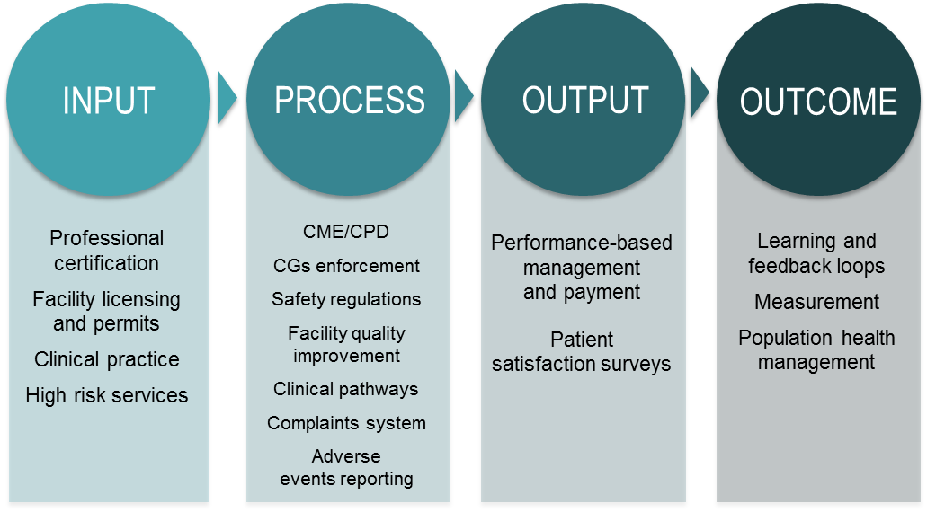
Source: WHO European Centre for Primary Health Care.

Setting and enforcing standards

The Ministry of Labour, Health and Social Affairs sets standards for quality assurance mechanisms such as licences, permits and technical regulations in accordance with international requirements and the participation of professional associations. There are standards for professionals, facilities, pharmaceuticals, laboratories, infectious disease control and high-risk services such as blood banks, pathology, ophthalmology and clinical practice.

The State Agency for the Regulation of Medical Activities of the Ministry of Labour, Health and Social Affairs is the main implementer of the mechanisms to ensure the quality of input to the health system. The Agency’s current role in quality assurance of primary health care is limited overall, with standards related to primary health care lacking. Developing standards for primary health care facilities is recognized as a priority, as detailed in the Primary Health Care Development Strategy. A Professional Development Council carries out professional certification, and the Department of Healthcare of the Ministry of Labour, Health and Social Affairs acts as the secretariat of the Council.
Professional certification. The regulatory division of the Ministry of Labour, Health and Social Affairs develops standards for the health workforce. The Professional Development Council under the Ministry is the implementing body in certifying doctors. This certification is not time-bound, and no recertification process is yet in place. Concerns were raised anecdotally on the standards of the certification exams. These tests currently comprise multiple-choice questions and do not test practical skills. Diplomas and specialization certificates were described to inform the initial contracting and employment of practitioners at health facilities.

Facility licensing and permits. Georgia has three main regulatory mechanisms for health facilities: licensing, permits and technical regulations. The regulatory division of the Ministry of Labour, Health and Social Affairs develops standards for health facilities. These currently exclude primary health care centres. The State Agency for the Regulation of Medical Activities licenses facilities and issues permits. The issuing of technical regulations to deliver medical services requires submitting information on technical standards and can also include inspections to assess these standards in practice. These mechanisms are currently carried out as one-off tasks; for example, issuing initial licensing without a time-bounded element, issuing permits without inspection or only reactive inspection because of complaints, etc. Facilities that provide services under the universal health coverage programme need to comply with additional standards. There are currently no accreditation programmes for facilities.

Clinical practice. Georgia has about 35 clinical guidelines specific to primary care, and there is general awareness of their existence. There are no standardized procedures for developing, periodically updating and distributing clinical guidelines and training professionals. The development of the existing clinical guidelines has benefited from the involvement of professional associations, including the Family Doctors Association and the Physician Association. Some private providers have implemented internal clinical protocols based on national or international standards. Compliance with clinical guidelines is not audited, unless there is a complaint and further investigation by the Ministry of Labour, Health and Social Affairs or by the insurer. The availability of clinical guidelines at primary care and referral health facilities and their easy accessibility at the website of the Ministry of Labour, Health and Social Affairs represents one of the potential strengths for quality assurance.

High-risk services. There are technical regulations for high-risk services such as ophthalmology and gynaecology. The State Agency for the Regulation of Medical Activities makes in-person inspections to ensure compliance. These inspections do not currently apply to primary health care.

Table 7 summarizes the existing mechanisms for quality assurance of inputs, highlighting the lack of mechanisms for primary health care.

Mechanisms for ensuring quality of processes

Continuing medical education and continuing professional development. The law mandating continuing medical education and continuing professional development was repealed in 2007. As a result of this gap in the regulatory framework, the quality of training is not standardized and training is not informed by practitioners’ actual needs rather than management interests. Similarly, no evidence indicates that the training is implemented in accordance with health outcomes and the priorities of the Ministry of Labour, Health and Social Affairs. There is currently no oversight over continuing medical education and continuing professional development that ensures that these learning systems are in place and happen regularly.

Table 7. Summary of mechanisms for assuring quality of inputs
 | Professionals | Inpatient facilities | Outpatient facilities and services | Primary health care
Enter market practice | One-off certification  No recertification | Licences (such activities as pathology and blood banks) and permits for an indefinite time issued by State Agency for the Regulation of Medical Activities | Some technical regulations regarding the infrastructure | None
Services delivery | No accreditation programmes | Internal minimum quality and safety requirements (quality committees) | Technical regulations for high-risk services such as surgery, obstetrics and gynaecology | None
Source: WHO European Centre for Primary Health Care.

Facility managers have autonomy to tailor continuing medical education and continuing professional development to their priorities. A variety of arrangements were recorded in terms of the scale, frequency and modes of these initiatives. The National Family Medicine Training Centre, for example, has designed courses and ad hoc training for family doctors and nurses working at the Centre. Professional associations are also active in developing content and implementing continuing medical education and continuing professional development. This includes a high level of activity by the national nursing association in supporting continuing medical education and continuing professional development in nursing services. Family doctors expressed particular interest for training on patient counselling on risk factors for noncommunicable diseases.

Building on existing continuing medical education and continuing professional development initiatives will be key to promoting a bottom-up approach to quality. These continuing medical education and continuing professional development initiatives need to be further aligned with national health priorities to multiply the positive effect and achieve more rapid results in terms of health outcomes. Box 3 provides an example of existing innovations in continuing medical education and continuing professional development.
Box 3. Innovations in continuing professional development

The chief nurse of the critical care unit at the Gudushauri Multiprofile Hospital felt that she needed to support her nursing staff with continual learning opportunities to maintain their competencies in caring for patients. The chief nurse, realizing that she needed support to gather all the most up-to-date knowledge, reached out to the Georgian Nursing Association. The Georgian Nursing Association prepared a 10-module programme in general nursing to run over two years. The modules cover such topics as monitoring medication and polypharmacy, providing antenatal care, infection control, emergency care, monitoring and managing diabetes, patient-centred communication and documentation. Nurses take the classes in their free time within the one- to three-month time frame that the courses are made available. Nurses pay a total of 10 lari (about US$ 4) per month to subsidize the training. The programme is now moving into its second year. The chief nurse has worked closely with hospital management and the Human Resources Department to organize the space and times of the training. As soon as the training period ends, the hospital will evaluate the project and look into a long-term training and funding scenario. Their hope is to tailor the training to the specific areas of emergency medicine, paediatrics, anaesthesiology and critical care.

Source: WHO European Centre for Primary Health Care.

Enforcement of clinical guidelines. External routine system for auditing compliance to clinical guidelines is absent. However, it was observed that some private providers adopt protocols based on national or international clinical guidelines supported by internal quality improvement mechanisms that ensure compliance at facilities level. Compliance to clinical guidelines in primary care is not audited, unless there is a formal complaint in which case an investigation is made by Ministry of Labour, Health and Social Affairs or by the private provider network.

Mechanisms for improving quality in hospitals. Several internal quality improvement mechanisms are in place at the national, regional and district hospitals (10). Each hospital has a designated quality committee or department responsible for implementing regular clinical audit processes aimed at improving patient care and outcomes by systematically auditing the services provided. This is done by checking and reviewing patients’ clinical histories. In addition, adverse events, outcomes and patient complaints are also reviewed. The results of these reviews by case or event are duly recorded in reports of the meetings and are communicated internally to clinical directors and the heads of clinical departments and doctors for appraisal or punitive purposes, learning and implementing change. How these mechanisms improve quality is not currently assessed or followed up.

Other mechanisms for improving quality include routine checks of medical records, reviews of complicated cases and data submission for reporting to the National Centre for Disease Control and Public Health conducted by heads of departments and randomly by hospital managers and/or clinical directors. Finance departments conduct administrative checks of medical records to assess the quantity of services delivered versus those claimed. Human resources departments report checking doctors’ diplomas and specialization certificates to determine their eligibility for practice.

The described mechanisms for improving quality at the hospital level provide a strong platform to build a similar system in primary health care.

Box 4. Peer-review meetings

Visits to three hospitals – Iashvili Central Children Hospital, Gudushauri Multiprofile Hospital and Sartichala Rural Ambulatory Centre – revealed all hospital health-care staff participate in regular (weekly) peer-review meetings, resulting in collegial well-informed consensus regarding conclusions, lessons learned and operational decisions. The existence of such a platform was consistently described at all three hospitals visited. This mechanism complemented by functioning quality improvement structural units represents one of the major strengths of the approach to quality in Georgia. Further development and fine-tuning at the hospital level may be needed but, most importantly, a version tailored to primary health care is required.

Source: WHO European Centre for Primary Health Care.

Clinical pathways. The scope of services that family doctors and narrow specialists should deliver have not been distinguished. This distinction will be deduced from clinical guidelines and by the competencies of each family doctor. There is no mechanism for assessing the appropriateness of referral to specialists.

Complaint system. A national patients’ charter is in place as well as a mechanism to capture patients’ complaints. There is also a national toll-free number for patients to file complaints about the care received. These mechanisms, however, are not standardized and not systematically implemented across facilities. During the field visits, it was observed that only some facilities have complaint boxes and advertise the toll-free number. Complaints received predominately refer to issues related to the coverage of services and disputes about access to services because of residence or registration lists.

Adverse event reporting. Reporting of adverse events is a key mechanism to ensure patient safety. It includes reporting the side-effects of medicines and vaccines, medical device adverse incidents and defective, counterfeit or fake medicines or medical devices. At present, Georgia has no mechanism for reporting adverse events. Georgia does not apply the Yellow Card Scheme – an international standard vital in helping countries to monitor the safety of all health products to ensure that they are acceptably safe. The facilities visited had no practice of reporting adverse drug reactions, except for discussion in the quality committee. Some facilities report adverse events to pharmaceutical companies.

Mechanisms for ensuring the quality of outputs and outcomes

Performance-based management and payment. Georgia has vertical initiatives monitoring output in primary health care, such as immunization, but a comprehensive and standardized monitoring scheme is missing. The current payment model for primary health care is mostly based on inputs, such as salaries for family doctors and nurses and the number of patients enrolled with primary health care providers. This excludes output and outcome factors such as sex, age, burden of disease, quality of care, patient experience and population health. Based on initiatives of the Global Fund to Fight AIDS, Tuberculosis and Malaria, there are intentions to pilot result-based payment for TB services. Further, the Tbilisi Primary Care Training Centre has mechanisms that monitor medical practice that are considered to financially reward family doctors as part of a pay-for-performance initiative.

Patient satisfaction surveys. Information about patients’ experiences and satisfaction are not systematically collected. Some private facilities collect data on patients’ satisfaction and experience, mostly waiting times.

Measuring outcomes. Georgia has no overall system to report on population health outcomes. Currently, the National Centre for Disease Control and Public Health measures population health as part of its population health surveillance. This reporting primarily involves rates of communicable diseases. The findings of this surveillance are published in an annual health statistics yearbook. Ad hoc assessments of health outcomes are also reported, such as the WHO STEPwise approach to Surveillance (STEPS) for risk factors for noncommunicable diseases, the Childhood Obesity Surveillance Initiative and the National Reproductive Health Survey.

Policy directions for improvements

Opportunities for strengthening the system for primary health care delivery

Modern health systems have diffuse lines of accountability. Georgia is no exception and faces common governance challenges stemming from multiple and relatively autonomous private providers that are difficult to hold accountable for outcomes, lack of enforcement mechanisms, weak subnational capacity to implement policies and the lack of a culture of learning loops driven by performance at the policy, managerial and clinical practice levels. Annex 1 shows a multi-stage process for strengthening primary health care governance.

Defining the scope of practice

Overall, primary health care actors have the needed competencies for delivering primary health care services and understand the underpinning principles of a holistic approach to health care. However, they do not constitute a network of providers guided by a shared vision of primary health care, since there is no primary health care identity that would enable roles and responsibilities to be defined and hold providers accountable for the outcomes. Fragmented systems for primary health care delivery hinder performance in terms of quality and efficiency. This results in a narrow scope of practice for primary health care and gaps in services delivery, especially related to noncommunicable diseases.

In the current situation of multiple actors at different levels of government and across the public and private sectors, defining the scope of practice of primary health care will enable roles and responsibilities to be established for actors that will be held accountable and will ensure that there are no gaps or duplication in the delivery of services.

The Primary Health Care Consultative Committee can play a key role in defining the scope of practice for primary health care and the competencies required for primary health care personnel.

Strengthening accountability for performance

A map of current services along the continuum of care, settings and actors with accountability links is needed to give priority to areas in which the accountability arrangements are the weakest and may have the greatest negative impact on health services delivery.

Primary health care needs to be reorganized into multidisciplinary teams, making use of the health-care personnel available through the parallel systems for primary health care delivery (universal health coverage, rural doctors and other disease-specific vertical programmes), who will then be held accountable for performance indicators.

Family doctors and specialists are often located in the same premises which provides a unique opportunity to strengthen interdisciplinary collaboration around specific and measurable health gains.

The Ministry of Labour, Health and Social Affairs needs to develop performance indicators for primary health care with the participation of professional associations and other primary health care actors. Capacity to monitor performance indicators is needed at the national and subnational levels. The Primary Health Care Consultative Committee may be well positioned to track progress against targets and, at the subnational level, the public health centres in the rayons could monitor the performance of primary health care if capacity is built. They conduct immunization and communicable disease and sanitary surveillance; this capacity could be increased to include monitoring the performance for priority conditions.

Accountability links for rural doctors should be strengthened by requiring them to report data on performance indicators to the Ministry of Labour, Health and Social Affairs via public health centres. Further, supervision and continuing professional development need to be implemented to address areas of improvement.

Pay-for-performance schemes should continue to be piloted to find an effective scheme to align desired performance and incentives for all primary health care actors: individuals as well as organizations.

Improving data access to enable feedback loops

Limited use of data for learning and driving performance improvements in policy, management and clinical practice creates an obstacle to accountability. Georgia has no feedback mechanisms.

Information sharing can be improved by establishing shared health records in outpatient care and guaranteeing access to timely and appropriate information by those who deliver primary health care. This will both strengthen the virtual primary health care teams and contribute to building a platform for continual feedback and learning to improve performance.

The type of information currently collected and reported at the facility level, mainly about volume, can be expanded slowly to include performance indicators about the four priority conditions identified by the Ministry of Labour, Health and Social Affairs and for which essential medicines are provided to the most vulnerable segments of the population.

Data flow in one direction from facilities to the Ministry of Labour, Health and Social Affairs via the National Centre for Disease Control and Public Health and its regional centres. Public health centres in the rayons can play a role in feeding the information back to the facilities for benchmarking and learning. Information can be discussed at bimonthly meetings with primary health care managers and public health centre directors.

Information generated about primary health care performance needs to be analysed at the Ministry of Labour, Health and Social Affairs level, for example, by the Primary Health Care Consultative Committee, and can then inform decision-making and priority-setting.

Increasing regulatory capacity

Georgia has good regulatory capacity, but enforcement is limited since there are no inspections, supervision, audits and overall feedback. Regulations targeting primary health care are lacking.

Standards for primary health care need to be developed in accordance with international standards.

Human resources planning for the State Agency for the Regulation of Medical Activities is needed to ensure that sufficient personnel are available to enforce compliance with standards and technical regulations in primary health care.

Building capacity at the subnational level

The subnational level has limited capacity to implement policies. Many actors are involved without coordination locally, since all report to the national level. The subordinate units of the Ministry of Labour, Health and Social Affairs have a limited presence at the subnational levels. Subnational oversight of population health management is lacking. Regions, municipalities, Social Security Agency branches, public health centres, rural doctors, disease-oriented programmes, other regional, municipal and national programmes and private for-profit and not-for-profit initiatives working without direction and community orientation also hinder the quality and efficiency of primary health care.

The roles of some subnational actors such as the public health centres need to be strengthened or expanded to provide oversight of the measurement of performance, enable information exchange and establish learning loops.

A “champion rural doctor” can be identified in facilities in charge of monitoring performance indicators and reporting them to the Ministry of Labour, Health and Social Affairs via the rayon public health centre. The champion rural doctor can also serve as the main liaison between the public health centre and the facility to disseminate policies and programmes and lead in implementation.

Opportunities for improving quality in primary health care

Overall, Georgia’s health system exhibits a range of mechanisms to assure, manage and improve quality. Some mechanisms related to assuring the quality of inputs and processes need to be strengthened; others need to be introduced, specifically those related to ensuring the quality of outputs and outcomes. However, these mechanisms are mostly not systematically applied in primary health care.

Strengthening mechanisms to assure the quality of primary health care inputs

Georgia has a relatively solid foundation of mechanisms to assure the quality of inputs and processes that can be leveraged to include primary health care. Some proposed measures are listed below.

Human resources for health. Setting standards for professional certification; licensing health professionals by competencies; and introducing time-bounded licensing and recertification.

Clinical practice. Standardizing clinical practice; and developing a regulatory framework that details the processes for the timely development, adoption, dissemination, implementation, monitoring and updating of clinical guidelines.

Health facilities. Developing ad hoc or extending current standards and regulations to include primary health care facilities; licensing and issuing permits for primary health care; introducing time-bound licensing and permits; implementing inspections of facilities by the State Agency for the Regulation of Medical Activities for surveillance of standards over time, including a mandate to revoke licences based on the findings.

Improving and consistently applying mechanisms for improving the quality of primary health care processes

Continuing medical education and continuing professional development. Aligning continuing medical education and continuing professional development with national priorities and improving its supervision; developing a mandatory continuing medical education system for primary health care, with a designated point person in the Ministry of Labour, Health and Social Affairs to oversee implementation and take stock of existing practices, resources and training centres; ensuring stakeholder involvement, including associations and universities in developing the improvement and implementation of primary health care training; diversifying methods for training and resources, including online eLearning and decision aids; introducing accreditation criteria that require onsite learning opportunities specific to primary health care, such as journal clubs, developing learning plans, lunchtime lectures, peer teaching on topics related to practice, peer reviews of cases and interprofessional role playing, which can be funded by accreditation fees; expanding skills could also include improving interprofessional practice and improving disease prevention and managing disease in the community.

Enforcing clinical guidelines. Introducing internal and external mechanisms for monitoring compliance with clinical guidelines; designing care pathways, including criteria for referrals and hospitalization; developing a checklist for implementing clinical guidelines that should address at least: facility governance arrangements to support the implementation of clinical guidelines, awareness and dissemination, clinical education and quality and safety; and improving processes for counter-referral and patient follow-up in primary care, including transferring discharge letters.

Establishing patient safety regulations. Introducing international standards for patient safety measures; investing in systems for monitoring administrative errors, diagnostic errors, medication errors and transitions in care; and ensuring the consistent use of quality committees, including systematically examining clinical priorities and assessing clinical outcomes and clinical learning.
Mechanisms for patients’ complaints. Disseminating formal mechanisms in facilities to gather patients’ complaints and patients’ experience while strengthening the capacity of the Ministry of Labour, Health and Social Affairs to follow up.

Reporting adverse events. Establishing conditions and a system to promote the reporting of adverse events through anonymous reporting; and ensuring that a monitoring programme for adverse drug reactions is introduced in accordance with international standards, with the interested parties including all health-care establishments, the Pharmacological Committee of the Ministry of Labour, Health and Social Affairs, professional medical organizations and the Uppsala Monitoring Centre, WHO Collaborating Centre for International Drug Monitoring.

Continuing piloting and standardizing mechanisms for assuring quality in the outputs of primary health care

A culture of performance monitoring and feedback needs to be developed at both the system and provider levels, especially emphasizing analysis, reporting and feedback.

Performance-based management and payment. Continuing and expanding the piloting of results-based funding of primary health care, including planned application to TB services. Continuing piloting total quality management in primary health care facilities.

Information reported by patients. Standardizing mechanisms for collecting and analysing experiences patients report on such factors as the patient-centeredness of care and the coordination, comprehensiveness and continuity of services.

Establishing mechanisms for improving the quality of primary health care outcomes

Learning and feedback loops. Establishing mechanisms for feedback and learning; driving the health workforce to focus on health outcomes; and building on existing practices such as the model for clinical care coordinators for improving maternal and child health in pilot facilities coordinated by UNFPA.

Outcome measurement. Standardizing the coding requirements and harmonize the use of ICD-10 coding for patient records in both primary health care and hospitals and for data reporting to the National Centre for Disease Control and Public Health; enabling data aggregation regionally to inform regional health strategies; and strengthening accountability for the outcomes of primary health care facilities.

Final remarks

Accelerating the responsive capacity to keep pace with changing health and social needs in Georgia seems imperative. Health needs and the burden of diseases have drastically changed, and the system appears strained to keep pace.
Proven cost-effective interventions at both the population and individual levels require efforts to invest in developing a primary health care approach, also in accordance with global and regional commitments.
The universal health coverage programme is a window of opportunity for improving primary health care governance and quality since it focuses on services delivery. It presents an opportunity for aligning and consolidating vertical efforts into a horizontally integrated platform of services with a higher capacity to resolve and better quality.
A model of care based on strengthening the primary health care approach that puts people at the centre can facilitate this. Achieving this requires collective understanding and agreement on a people-centred approach to services delivery to adjust people’s perceptions and professional practice.
Increasing the capacity to resolve of the first level of care will ensure the sustainability of the universal health coverage programme efforts, generating internal efficiency gains in the long run.

References

- Georgia: Health system review. Health Systems in Transition, 2017. Forthcoming.
- Primary healthcare system’s development strategy and its implementation plan. Vienna: Global Alliance for Health and Social Compact; 2016.
- Health system quality improvement strategy. Vienna: Global Alliance for Health and Social Compact; 2015.
- European Framework for Action on Integrated Health Services Delivery: and overview. Copenhagen: WHO Regional Office for Europe; 2016 (http://www.euro.who.int/en/health-topics/Health-systems/health-services-delivery/publications/2016/the-european-framework-for-action-on-integrated-health-services-delivery-an-overview-2016, accessed 9 March 2018).
- Noncommunicable disease country profile: mortality structure, Georgia. Geneva: World Health Organization; 2014 (http://www.who.int/nmh/countries/geo_en.pdf, accessed 9 March 2018).
- Global burden of disease: Georgia country profile. Seattle: Institute for Health Metrics and Evaluation; 2015 (http://www.healthdata.org/georgia, accessed 9 March 2018).
- European Centre for Disease Prevention and Control and WHO Regional Office for Europe. Tuberculosis surveillance and monitoring in Europe 2017. Stockholm: European Centre for Disease Prevention and Control, 2017 (https://ecdc.europa.eu/en/publications-data/tuberculosis-surveillance-and-monitoring-europe-2017, accessed 9 March 2018).
- Health care statistical yearbook 2015. Tbilisi: Ministry of Labour, Health and Social Affairs, National Centre for Disease Control and Public Health; 2015 (http://www.ncdc.ge/AttachedFiles/yearbook%202016_53210b52-12da-4279-9f27-f7a361c84c96.pdf, accessed 9 March 2018).
- Georgia STEPS survey 2016. Fact sheet. Geneva: World Health Organization; 2016 (http://www.who.int/chp/steps/Georgia_2016_STEPS_FS.pdf?ua=1, accessed 9 March 2018).
- Order no. 01-63/N dated September 12, 2012. Requirements towards internal quality improvement and patient safety systems in inpatient medical facilities providing medical services. Tbilisi: Ministry of Labour, Health and Social Affairs; 2012.

Annex 1. Multi-stage process for strengthening primary health care governance

This annex presents an example of how the recommendations mentioned above can be put into operation by focusing on one or more priority diseases and implementing a long-term concurrent multi-stage process (Fig. 1).
The scope of primary health care that defines the roles and responsibilities of actors currently involved in delivering primary health care services could be expanded by establishing virtual primary health care teams that network existing actors through concrete tools, such as patient pathways, health records and discharge plans, and creates a niche for family doctors, such as care and case managers and coordinators. Focusing on performance in priority diseases, for example, could facilitate the development of the health system capacity to regulate primary health care, align incentives and update the competencies of the health workforce, also at the subnational level.

Fig. 1. Multi-stage process for strengthening primary health care governance

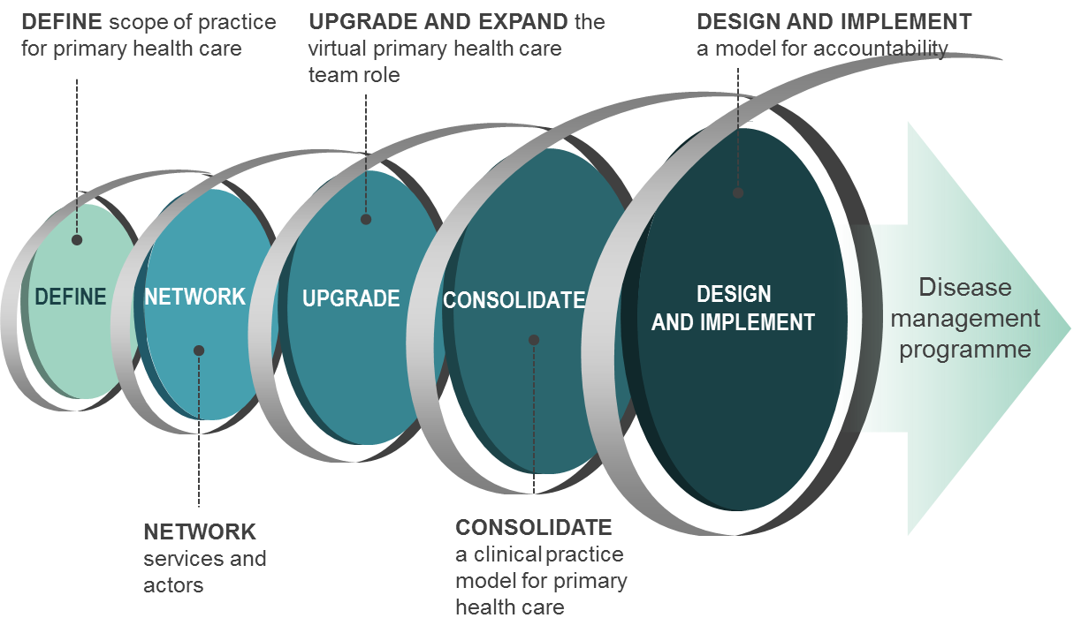
Source: WHO European Centre for Primary Health Care.

Manage networks of actors and services
Tools need to be applied to connect virtual primary health care teams around previously agreed outputs and outcomes. Examples of tools are patient pathways and discharge plans. Increasing the capacity to manage services, a key process for translating policies into practice, will be important in providing guidance and supervision to the virtual primary health care teams. This oversight role needs to exist at the facility level and at the subnational level.

Upgrade and expand the role of the virtual primary health care team
New services can be introduced, especially to fill critical service delivery gaps in prevention and treating noncommunicable diseases. This requires upgrading the competencies of providers, developing new standards and implementing incentives aligned around the new services. For example, competencies related to screening, health literacy and healthy lifestyles are needed to address noncommunicable diseases.

Consolidate a clinical practice model for primary health care
With upgraded and expanded primary health care teams, a clinical practice model for primary health care can be consolidated by harmonizing the basket of services, competencies, the scope of practice (rural versus urban and private versus public) and standards. The clear delineation of the scope of practice for primary health care actors based on clinical guidelines and protocols will promote standardization across the parallel systems for delivering primary health care services and guarantee improved performance and increased efficiency. The regulatory underpinnings of this clinical practice model will be needed, with the development of standards and mechanisms to regulate and enforce them. Financial incentives will also need to be aligned to achieve the desired performance of the clinical practice model for primary health care.

Design and implement a model for accountability
Based on the initial mapping of current actors and accountability links, an accountability framework is to be designed and implemented to improve the governance of all primary health care actors around results and health outcomes. Clear accountability arrangements need to be established, well-resourced and provided with guidance. Three important processes need to be guaranteed within the accountability model: setting performance targets, generating information on performance and ensuring feedback loops for accountability:

- setting performance targets for both the health system and each facility;
- generating and disseminating information on performance for stakeholders, including engaging regional and local actors to monitor accurate information production and sufficient information flow; and
- making feedback more timely to improve performance and learning through effective accountability chains.

For individual primary health care providers, appropriate reward structures, increased employment status and improved supervision and reporting can contribute to a solid accountability framework. Building on existing values regarding the responsibility of primary health care providers for their catchment population will be key to strengthening accountability linkages.


World Health Organization Regional Office for Europe
UN City, Marmorvej 51, DK-2100 Copenhagen Ø, Denmark
Tel: +45 45 33 70 00 Fax: +45 45 33 70 01
Email: eucontact@who.int
Website: www.euro.who.int
The WHO Regional
Office for Europe

The World Health Organization (WHO) is a specialized agency of the United Nations created in 1948 with the primary responsibility for international health matters and public health. The WHO Regional Office for Europe is one of six regional offices throughout the world, each with its own programme geared to the particular health conditions of the countries it serves.

Member States

Albania
Andorra
Armenia
Austria
Azerbaijan
Belarus
Belgium
Bosnia and Herzegovina
Bulgaria
Croatia
Cyprus
Czechia
Denmark
Estonia
Finland
France
Georgia
Germany
Greece
Hungary
Iceland
Ireland
Israel
Italy
Kazakhstan
Kyrgyzstan
Latvia
Lithuania
Luxembourg
Malta
Monaco
Montenegro
Netherlands
Norway
Poland
Portugal
Republic of Moldova
Romania
Russian Federation
San Marino
Serbia
Slovakia
Slovenia
Spain
Sweden
Switzerland
Tajikistan
The former Yugoslav
Republic of Macedonia
Turkey
Turkmenistan
Ukraine
United Kingdom
Uzbekistan

The Yellow Card Scheme is based on the ICS E2B (R2) international standard and routinely used in the European Union, the United States of America and many other countries reporting all adverse drug reactions to the international database centre and laboratory of the Uppsala Monitoring Centre, WHO Collaborating Centre for International Drug Monitoring in Uppsala, Sweden.

